A picture containing clipart

Description generated with very high confidence

Azure 103 Module 2

Hands On - 16

Azure Certification Training

[**support@intellipaat.com**](mailto:support@intellipaat.com)

**+91-7022374614**

**US: 1-800-216-8930(Toll Free)**

**Azure 103 Module 2, Hands On – 16**

**Using AZCopy.**

**Step 1:** Create two storage accounts (e.g. azcopysrc and azcopydemodest).

**Step 2:** Go to these Storage Accounts and click on Access Control IAM.

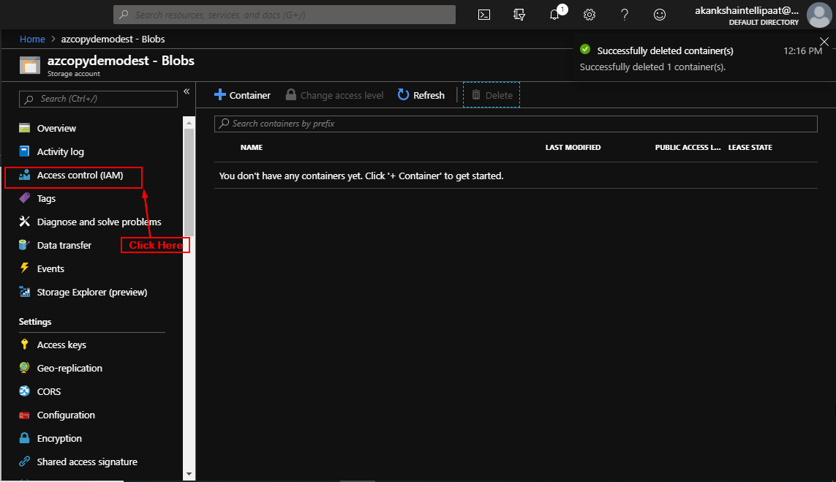

**Step 3:** Click on Add > Add Role Assignments. Click on Add > Add Role Assignments.

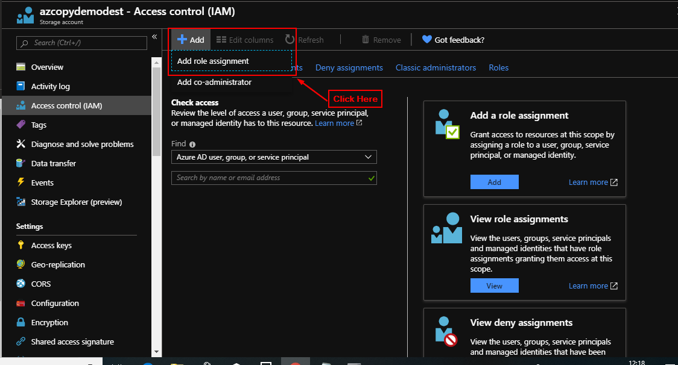

**Step 4:** Select "Storage Blob Data Contributer" as Role and Select your email address from the list as Selected Member and Click Save (Do this for both storage accounts source and destination).

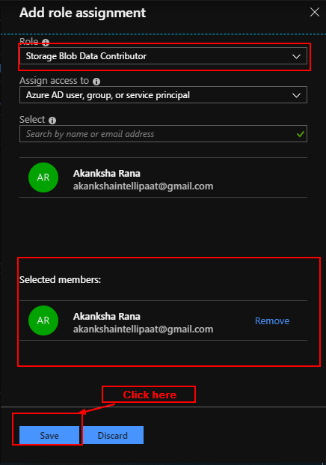

**Step 5:** Open a storage account generate and copy it's Blob Service SAS URL (Do this for both storage accounts (source and destination)).

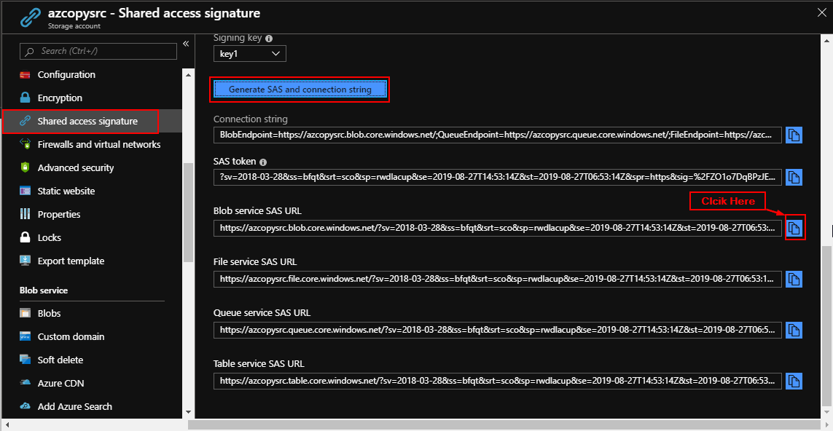

**Step 6:** Download azcopy from this URL: <https://aka.ms/downloadazcopy-v10-windows>.

**Step 7:** Extract it to a folder and open Terminal/CMD in that folder.

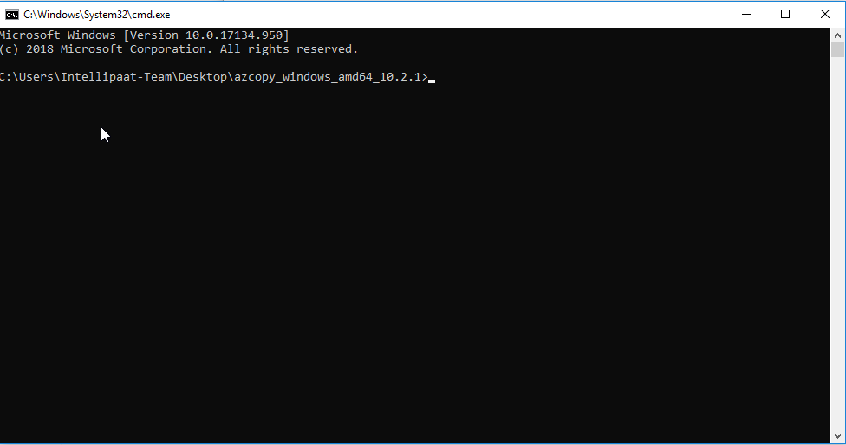

**Step 8:** azcopy login follow the instructions on the prompt (if it doesn't work Go to Azure Active Directory > Properties and Copy Directory ID and use command: azcopy long --tenant-id=<tenant-id> (replace tenant id with Directory ID you copied)).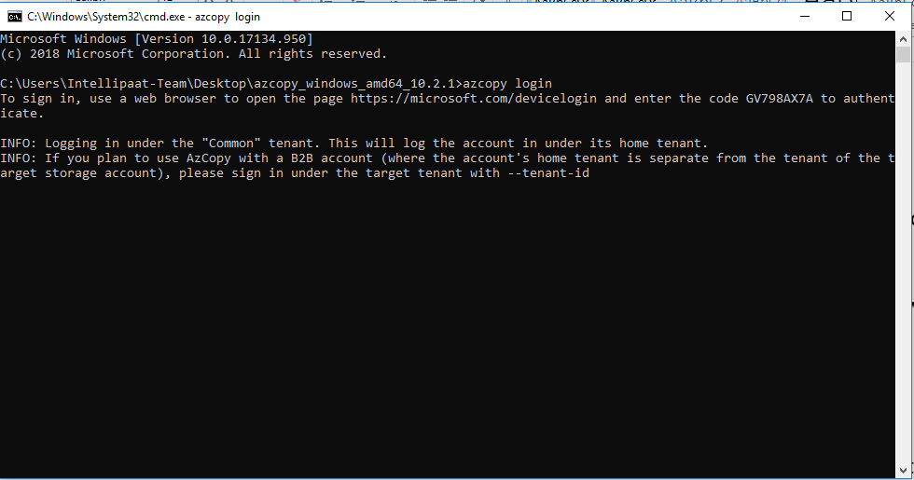

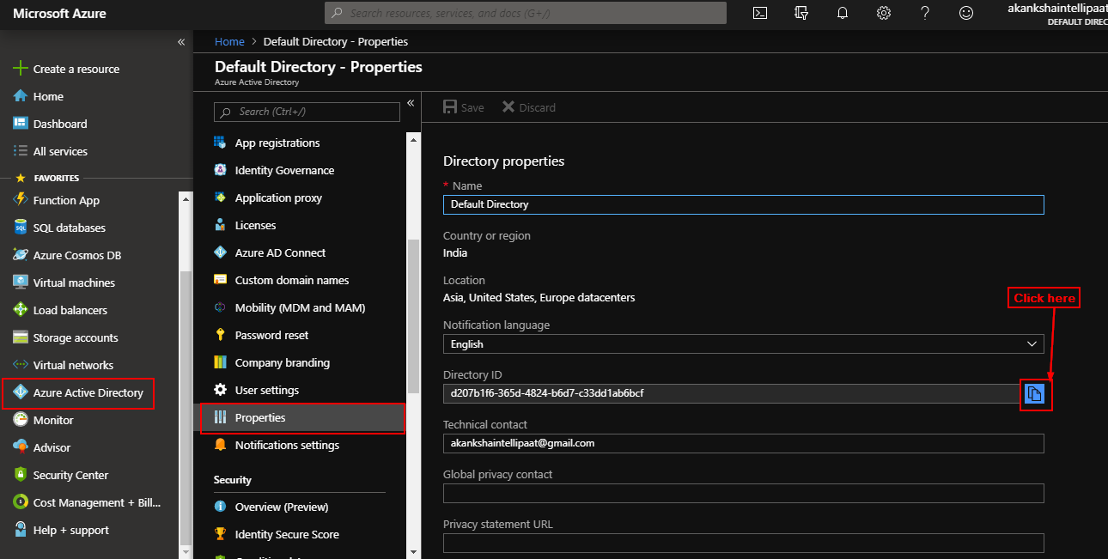

**Step 9:** After login type this command (replace first URL with source storage account url and SAS token and second with destination): azcopy copy "https://<source-storage-account-name>.blob.core.windows.net/<container-name>?<SAS-token>" "https://<destination-storage-account-name>.blob.core.windows.net/<container-name>?<SAS-token>" –recursive

